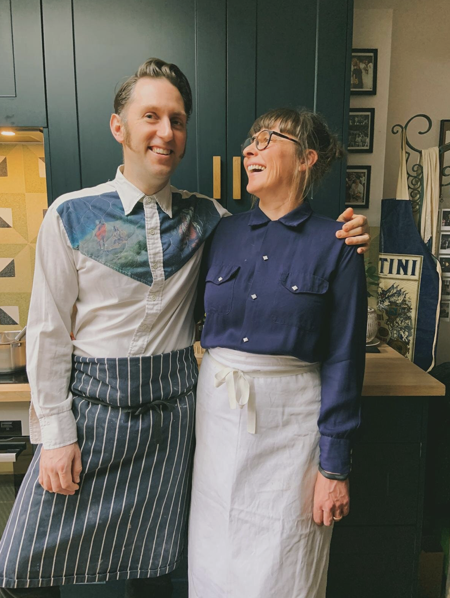
A bit about husband and wife team Henry and Laura.
Henry is a professional chef and has worked in kitchens for over 17 years, working as Head chef of Moro and Morito Exmouth Market. He was Head chef at Poco in Broadway Market and also worked at Hibiscus for Claude Bosi and Bathers Pavillion in Sydney. He then worked for Belazu as their innovation chef.
Laura comes from a different professional background, working as a Set Decorator in Film and Television for 17 years. After having an injury she decided to take a change in career, and pursue her passion for food.
Having seen many people we love struggle with mental health, they found that there was limited help available through the normal channels. They believe that the act of cooking can provide a sense of accomplishment and focus that can positively impact your sense of self-esteem. Three years ago they started free running cookery classes for charities, the aim to provide a comfortable and informal space where people can connect with others, practice mindfulness as well as learn a new life skill.
Henry and Laura have a real passion and will be creating a delicious menu for you every day.
A percentage of their profits from this retreat will be going to the mental health charities that they support.

